**Issue:** BVOIP Config Issue.

**Resolution:**

**Follow the below steps to find the BVOIP Error:**

1. We need to check the BVOIP error in USRP DB.
2. Open the below Arthur Sql Viewer URL.

**Arthur Sql Viewer URL:** [**http://moose.mt.att.com:8008/cgi-bin/gcsm/sql3html.pl**](http://moose.mt.att.com:8008/cgi-bin/gcsm/sql3html.pl)

1. Search the PVC_ID in pvc_feature_config table

select * from pvc_feature_config where pvc_id = 12777398

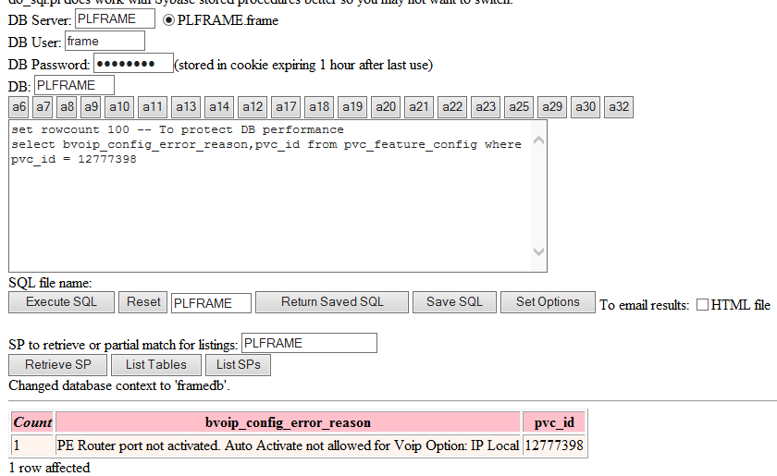

**Follow the below steps to check the status in ICORE:**

1. Open the below ICORE URL Click on Orders-----🡪 Order--🡪Search the connection id (ICORE_PVC_ID)

**ICORE** [**URL**:http://icoreweb.noc.att.com:5020/srchmenu.cgi?SrchAddCM=true](URL:http://icoreweb.noc.att.com:5020/srchmenu.cgi?SrchAddCM=true)**.**

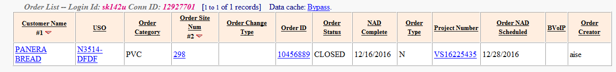

**BVOIP Error: PE Router port not activated. Auto Activate not allowed for BVOIP Option: IP Local**

Whenever you receive the above error, you need to go to the connection detail page in ICORE and click on the “Activate” link. Once the link is activated, EFMS can retrigger the request after 15-20 minutes.

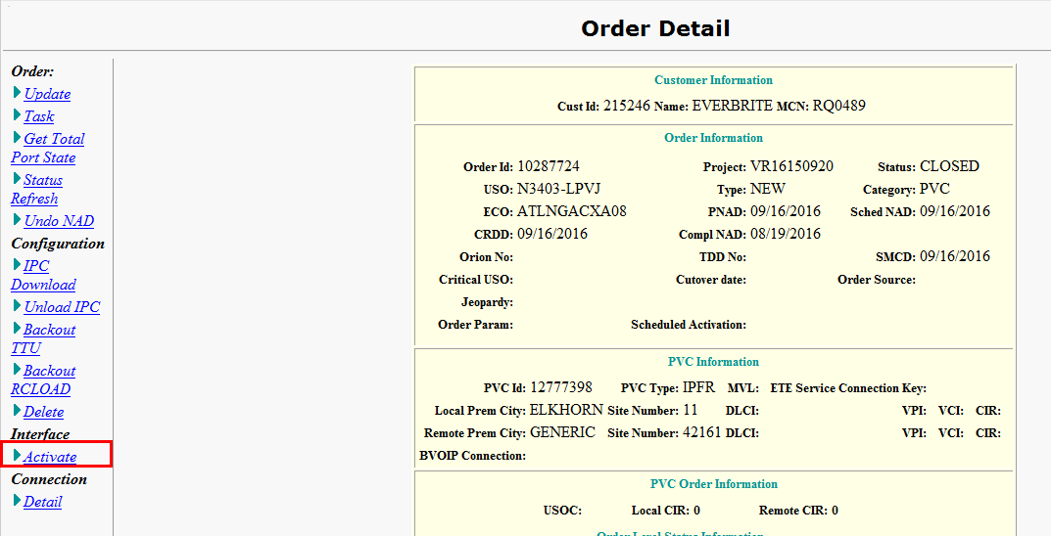

**Reference Tickets:** 224428600, 224792727, 225472561, 225611690

1. **BVOIP Error: Cannot create a BVOIP order when open MACD/port orders exist**

* If there is any previous open order in ICORE on site/pvc, user needs to get that order cancelled or NAD completed first.
* **Reference Tickets:** 224138132,224910481

1. **BVOIP Error: - Open change pvc order(s) already exist.**

* If there is any previous open order in ICORE on site/pvc, user needs to close the order.
* **Reference Tickets:** 226266540, 229390997

3. For the below mentioned BVOIP Error’s, we need check with ICORE:

(ICORE provide the WA for below mentioned Error’s)

|  |  |
| --- | --- |
| **BVOIP_CONFIG_Error_Reason** | Reference Ticket |
| Connection level BVOIP is set.Cannot Add the Order | 223815988 |
| dispMsg = "INSTAR error -" appendMsg = "Order not complete but MaintInd is on! Invalid state for setConnectionAttributes" : Request Id: icorefep3450 | 224792702 |
| VCSProv.modifyPvc(): java.lang.Exception: VCSProv.processReq(): java.lang.Exception: java.lang.Exception: class VCS.src.InstarRequest: modifyPvc(): java.lang.Exception: class VCS.src.InstarRequest: modifyPvc(): java.lang.Exce | 224992451 |
| dispMsg = "INSTAR error -" appendMsg = "New Start order is still in progress, retry the change order in 10 minutes." : Request Id: icorefep3342 | 225088449 |
| PE Router port not activated. | 226209863 |
| "INSTAR error -" appendMsg = "NTMS is out of synch with the router - Perform Real time discord analysis to load current config" | 225591278 |
| NULL | 226482326 |
| VCSImpl.modifyPvc()VCSProv.modifyPvc(): java.lang.Exception: VCSProv.processReq(): java.lang.Exception: java.lang.Exception: class VCS.src.InstarRequest: modifyPvc(): java.lang.Exception: class VCS.src.InstarRequest: modifyPv | 225885113 |
| dispMsg = "INSTAR error -" appendMsg = "No BVoIP Address for Pvc Id | 227338446 |
| dispMsg = "INSTAR error -" appendMsg = "Existing Port does not support new features-Messages: No available capacity at Port: mxtijn1001me205JU901001 As an initial data setup check, One reason could be port is NOT reserved cor | 227434831 |
| Unknown Error | 227222093 |
| com.informix.asf.IfxASFException: Attempt to connect to database server (icoreserver1) failed. | 227222093 |
| -dispMsg = "INSTAR error -" appendMsg = "Existing Port does not support new features-Messages: Allocation Status: 15088226/3, Failure ok3ca304me1: Router VRF Limit, allocated: 0.0 Failed: ok3ca304me10112C01000/1: Channel P | 226066794 |
| com.att.wn.aracs.ari.RouterLoadException: , Threw unexpected error : java.io.IOException: com.jcraft.jsch.JSchException: Session.connect: java.net.SocketException: Broken pipe : Ruby Transaction paid: 9833655 | 226761008 |
| dispMsg = "INSTAR error -" appendMsg = "Vrf name discord exist Vrf name discord exist " : Request Id: icorefep3130 | 226775044 |
| bvoip_config_error_reason:- Cannot create order - PVC should be IN-SERVICE before creating Change PVC order | 228082839 |

**NOTE: If you got any new error, except the above errors, then check with USRP first.**